**PROJECT:** **INSPONA Website**

**URL: https://INSPONA.com**

**Date Started: April 17, 2018**

**Date Finished: June 20, 2018**

**Steps**

**____ :RESEARCH**

**____ :DESIGN**

**____ :CONTENT**

**CODE: ____**

**TEST: ____**

**DEPLOY: ____**

**TECHNOLOGIES USED**

Signature: _________________________

Date: ________________________

**RESEARCH**

**DESCRIPTION**

INSPONA is a blog based website that publishes opinion reviews and informational articles on products, projects, services, and entertainment media. Most being hybrid between opinion and informational.

OPINION REVIEWS AND INFORMATIONAL ARTICLES

A taste of things that will be covered in the realm of reviews and informal articles are the following;

-Awwward website of the day,

-New tech products on the market,

-Tech news,

-New inventions,

-Movies,

-Music Albums,

-Podcasts,

-Books,

-shows

-youtube channels

-New services on the internet and market,

-Start-up companies,

-People (artists, CEO, Entreprenuars, historical figures, authors, etc.)

-New apps,

-New science discoveries,

-Weird history,

-miscellaneous products,

-how things work

**INSPONA-CAST**

Inspona-cast Podcast is a branch from the INSPONA blog that is a podcast going though some of the blog posts 2-3 times a week. Each main episode is to be 1-2 hours long and short episodes 15-45 minutes.

**LINKS THAT INSPIRE**

<https://gizmodo.com/>

<https://techcrunch.com/>

**PLANNING & CONTENT**

**Development and coding**

June 7-15

-Main goal is to get all of the frameworks completed so its an easy paste and set up to publish each of the articles.

-Another goal is to make it as mobile responsive as possible

**Parts**

**Homepage**

-Create the basic of the web page such as the main navigation parts.

-Create each of the layout containers, the large, small, medium, and extra large

**Article pages**

About [content]

INSPONA, INSPONA, INSPONA … It all began in a dark, musty, basement with the fluorescent blue lights of Christmas still hanging on the sad, naked, beige walls. Through the illumination of the light that bounced around in this cave of a basement sat a tall, lanky, nerd who’s title by most people was, Ashton, Ashton Pigsley. With this weird modern hobbit crouched over in his chair looking into the binary abyss of the internet through the receiver being a laptop, it began to dawn upon him in his stringy mind that he should start a blog of his own.

Through a week of exploring and adventuring for a title for this new canvas of art he was destined to build he found the name. While flipping through the thesaurus he found a word that glowed and beamed at him like a laser piercing through the pupil of an eyeball.  With this discovery he was convinced it must be incorporated into the legendary title.

With this word in mind he began to alter it for his own. The time finally came when he found the perfect word to call his blog, INSPONA. He new when he choose that name it must live upon a statement and that the phrase must live within every article. Through a lot of head banging, nail biting, pencil writing the phrase was created, **“teach the past, review the now, and imagine the future”**.

Through weeks of treacherous research and backbending self criticism the design was made and was ready to be developed, tested, and deployed as a website full of potential. Through the long nights, early mornings, and hours of dedication the masterpiece was finally complete. It was successfully deployed and lifted off in the July of 2018.

Since the deployment INSPONA has kept its golden phrase alive by incorporating it into every article by constructing three different domains of articles. The first domain being informational. INSPONA wants to give information about the now and the past to help with people's everyday hunger to know things. As well as to further inform readers about events, products, people, and more.

The next domain is reviews. INSPONA wants to provide reviews on products, services, media, and more to give the ultimate feelings and thoughts on those certain subjects. INSPONA doesn’t look to change your opinion but rather give viewers other peoples opinion that can guide them to their destined and correct decision.

The last and most important domain is the future. The future covers things ranging from futuristic ideas to how an innovations of today can change the future. With each of these domains chained together pumping each one to life INSPONA continues to live. It lives to teach the past. It lives to review the now. And most importantly it lives to imagine the future.

**Contact**

Want to contact us regarding one of the following things;

- Recommendations on the website or topics

- Issue Reporting

- Advertising on INSPONA

- Questions

- how amazing you are, what you had for breakfast, what your dog looks like

Email INSPONA at [ashtonpigsley@gmail.com](mailto:ashtonpigsley@gmail.com)

**Inspona-cast**

Coming in October of 2018 keep a heads up

**Subscribe**

What to be informed on new articles and INSPONA updates? Subscribe to our news letter by clicking this link.

**DESIGN**

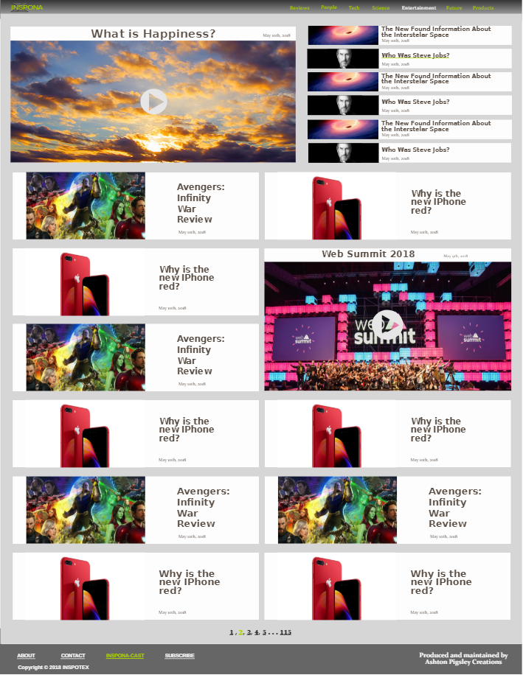

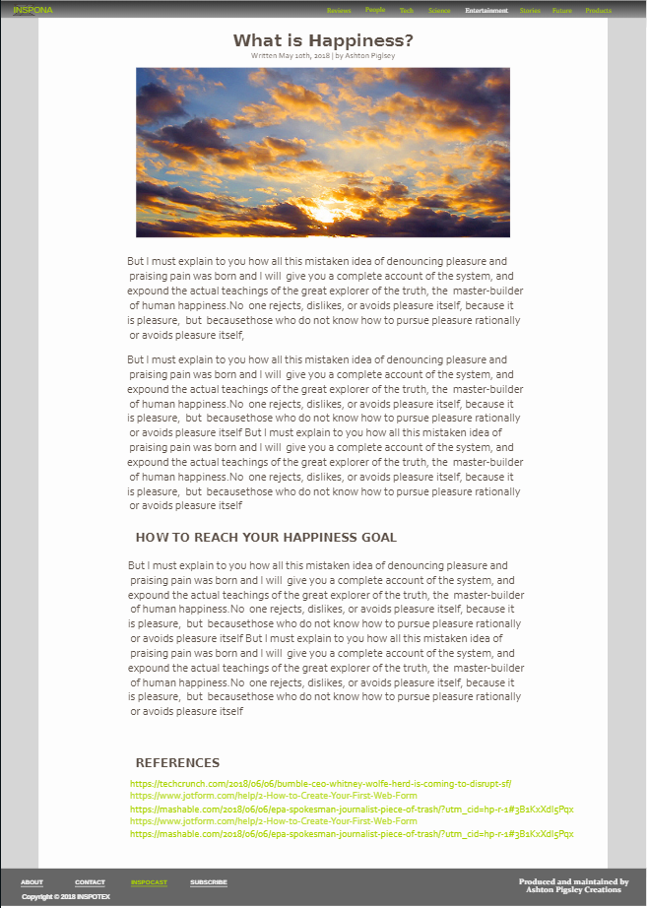

**CODE**

**DEPLOY**

**RESOURCES**

**BUG REPORTS**